REGULAR MONTHLY COUNCIL MEETING AGENDA
Monday, August 8, 2022 – 6:00 PM
City Hall, Molena, Georgia
- CALL TO ORDER
Mayor Corley
- PLEDGE/INVOCATION
Councilmember Damon Riggins, Post 2
- PUBLIC COMMENTS AND INVITED GUESTS
  - Citizen's Comments
    - General comments – 3 minutes
    - Public comments regarding playground to be heard after Reports from Council and Committees item A c
  - Invited guest –
    - Bryan Richardson – 5K Run
    - Bobby Bunn – Friends of the J. Joel Edwards Public Library – will be arriving late will speak at end of meeting
- APPROVAL OF AGENDA/APPROVAL OF MINUTES
  - Minutes of previous meeting(s) were provided to Council for approval.
a. Regular meeting Monday, July 11, 2022.
- CHIEF OF POLICE REPORT
  - See attached report – Chief Polk in Departmental meeting
  - Number of Calls & Citations – 119 Total incidents
    - 68 Traffic Stops
    - 2 Traffic Accidents
  - Status of Vehicles & Mileage
    - Explorer
    - Tahoe
    - Crown Victoria
  - Condition of vehicles
  - Balance Ford loan - $37,015.43
- Other business – K-9 Jax deceased Thursday, August 4, 2022
  - Laid to rest near Molena Police Department
  - Molena Police Officers will come to meet Council at some point during tonight’s meeting.
REPORTS FROM COUNCIL AND COMMITTEES
- Buildings, Streets and Grounds - Allison Turner
  - Hole @ Willis & Daniel fixed
  - Hole Railroad and Depot – fixed
    - See bill from Crawford Grading and Pipeline
  - City Park discussion
  - 56 Garland has been removed
- Public Safety - Damon Riggins
- Ways & Means - Luis Vazquez
- Technology & Engineering - Luis Vazquez
  - Update on City Broadband availability
- Water - Jennifer Riggins
  - Result of meeting with Hofstadter and Associates
  - Update on EPD requirements
- MAYOR'S REPORT
  - Update
- OLD/UNFINISHED BUSINESS
- Discuss Suez proposed contract
- New Business
- First reading of FTA Ordinance
- Crawford Grading and Pipeline Invoice approval
  - Paid. Need to transfer $676.00 from SPLOST fund to reimburse for Willis/Daniel repair.
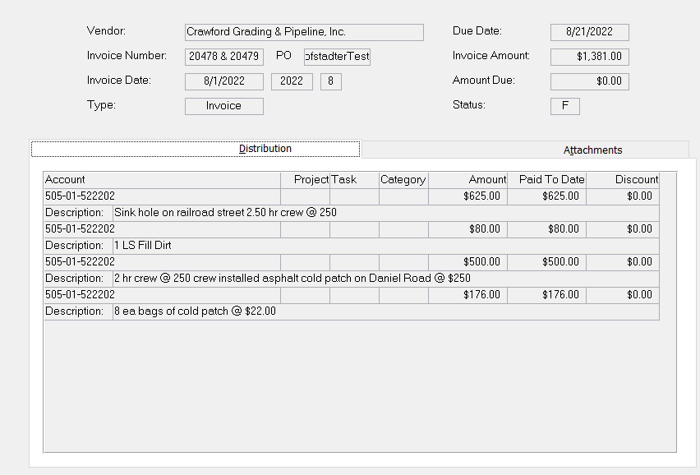
- EXECUTIVE SESSION
- ROUNDTABLE DISCUSSION
  - Councilmember Jennifer Riggins
  - Councilmember Damon Riggins
  - Councilmember Andrea Ashby
  - Councilmember Luis Vazquez
  - Councilmember Allison Turner
  - Mayor Joyce Corley
  - City Attorney Scott Mayfield
- NEXT REGULAR MEETING
  - Monday, September 12, 2022, 06:00 PM
- Budget Workshop Scheduled
- Budget workshop Monday, September 26, 2022, 06:00 PM
- ADJOURNMENT

