Molena City Council

PO Box 247 10 Spring Street Molena GA 30258

Meeting Minutes
Monday, August 8, 2022

- Call to order
Mayor Joyce Corley called to order the City Council meeting of the Molena, Georgia City Council at 6 p.m.
- Pledge and Invocation
Councilmember Damon Riggins, Post 2 led the membership in the Pledge of Allegiance to the American Flag followed by a brief prayer.
- Roll call
City Clerk Tina Lee conducted a visual roll call. The following persons were present: Mayor Joyce Corley; Mayor Pro Tempore Jennifer Riggins, Post 1; Councilmember Damon Riggins, Post 2; Councilmember Andrea Ashby, Post 3; Councilmember Luis Vazquez, Post 4, Councilmember Allison Turner, Post 5, and City Attorney L. Scott Mayfield. Also present were Chief of Police Matt Polk and City Clerk Tina Lee.
- Public Comments and Invited Guests
  - Public Comments
      - None
  - Invited Guests
    - Bryan Richardson
      - Discuss 5K/10K October 22, 2022, by American Legion
    - Brandon Rogers
      - Discuss LOST and take questions from Council
    - Bobby Bunn - Friends of the J. Joel Edwards Public Library
      - Request permission to hold Elkins Creek 5K and 1 Mile Fun Run/Walk
      - Will be held in conjunction with Molena Bigfoot Fest
      - Promised a full breakdown by next meeting
    - Comments from the public via telephone, email, Facebook, in-person visit to City Hall
      - None
- Approval of minutes from last meeting
Minutes from previous meetings were emailed to Council and posted on the web. Councilmember Damon Riggins, Post 2 moved to approve the current agenda and minutes with a second by Mayor Pro Tempore Jennifer Riggins, Post 1 .
- Chief of Police Matthew Polk
  - Chief of Police, Matthew Polk was in a Department Meeting, report read by Mayor Corley and discussed by Council
    - 119 Total incidents
      - 68 Traffic Stops
      - 2 accidents reported
  - Mileage on vehicles
    - Explorer 14,219
    - Tahoe 142,000"ish"
    - Crown Victoria 141,741
  - Explorer Loan Balance $37,015.43
REPORTS FROM COUNCIL AND COMMITTEES
    - Buildings, Streets and Grounds - Allison Turner
      - Hole @ Willis & Daniel fixed
      - Hole Railroad and Depot – fixed
      - See bill from Crawford Grading and Pipeline
      - City Park discussion
        - Hunter Wilson and family appeared before Council regarding the playset that was destroyed at the park.
        - Mr. Wilson did not take sole credit for the act, however, he apologized to the city for his part in the destruction of property and asked how he could make restitution.
        - Council ordered 25 hours of Community Service and gave suggestions for ways that service could be completed.
          - Mr. Wilson (Hunter's Dad) offered a piece of granite for Jax's grave.
          - Mr. Wilson (Hunter) will remove the wreckage of the playset over the weekend.
          - He will then volunteer after school on Fridays with Little Manna Foods.
          - Mr. Hunter Wilson will also work cleaning up the park to help complete his time.
          - Mrs. Wilson will advise City Clerk of work done. Time at Little Manna will be verified with Melanie Smith or Skip Ferron.
    - 56 Garland has been removed
    - Public Safety - Damon Riggins Nothing to report
    - Ways & Means - Luis Vazquez Nothing to report
    - Technology & Engineering - Luis Vazquez Nothing to report
    - Water - Jennifer Riggins
    - Result of meeting with Hofstadter and Associates
    - Update on EPD requirements
- MAYOR'S REPORT
  - Mayor provided an update on the meeting with Hofstadter and Associates
    - Will be our engineering firm.
    - Hofstadter will reach out to WRP regarding filtration
    - Is looking into other options as far as backup supply
  - Provided update re broadband
    - Backhaul established at Beckham
    - Should be available within two weeks to citizens on the south side of the city.
  - Update re meeting with Three Rivers
- OLD/UNFINISHED BUSINESS
- Discussed Suez proposed contract
  - Will sign contract next month
- New Business
- First reading of FTA Ordinance
- Crawford Grading and Pipeline Invoice approval
  - Paid. Need to transfer $676.00 from SPLOST fund to reimburse for Willis/Daniel repair.
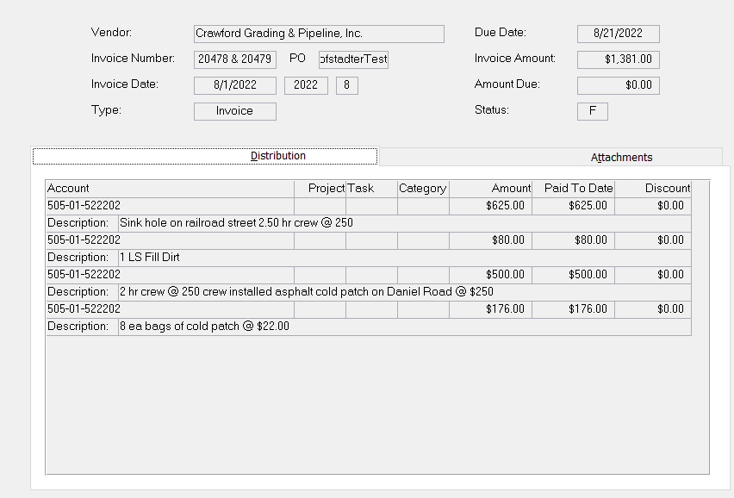
- Roundtable
  - Jennifer Riggins nothing to discuss
  - Damon Riggins nothing to discuss
  - Andrea Ashby nothing to discuss
  - Luis Vazquez nothing to discuss
  - Allison Turner nothing to discuss
  - Mayor Joyce Corley nothing to discuss
  - Chief Matthew Polk nothing to discuss
  - City Attorney Scott Mayfield nothing to discuss
- Adjournment
Mayor Joyce Corley adjourned the meeting at 7:11 p.m. following a motion by Councilmember Damon Riggins and a second by Councilmember Jennifer Riggins.
Minutes respectfully submitted by: City Clerk Tina L. Lee
Minutes approved by: ___________________

